“I can do everything through Him who gives me strength.” -- Philippians 4:13

- Please show all your work! No partial credit will be given for incorrect answers with no work shown. Please draw a box around your final answer.
- Calculators are permitted, but no notes, text, laptops, PDAs, or electronic dictionaries. Cell phones should be muted and left in your pocket or bag.
Total marks: 70

- Mark each of the following variables as categorical (G) (not ordinal), ordinal (O), discrete (D), or continuous (C). [5]
  - The birth weight of a newborn baby: Continuous
  - The province that a patient lives in: Categorical
  - The number of times a patient visits the hospital: Discrete
  - The blood type of a patient: Categorical
  - User satisfaction (excellent, good, fair, poor, very poor): Ordinal
- Give an example of a pair of events that are mutually exclusive. Be sure to define each event clearly. [2]
Many possible answers: male vs. female, heads vs. tails on a coin toss,
red vs. green in drawing a marble/
granola bar out of a bag, etc.
- Give an example of a pair of events that are independent. Be sure to define each event clearly. Also define the total sample space. [3]
There are many possible answers; a simple one is flipping a coin multiple times: the event “heads on first flip” is independent of the event “heads on second flip”. The whole sample space is { (H,H), (H,T), (T,H), (T,T) }.
- Assume the list below represents the raw data for an experiment measuring the systolic blood pressure of a sample of patients. Draw an (absolute) frequency histogram, classifying the data by tens of mmHg. [5]
100 mmHg | 106 mmHg | 116 mmHg
122 mmHg | 125 mmHg | 129 mmHg
131 mmHg | 139 mmHg | 148 mmHg
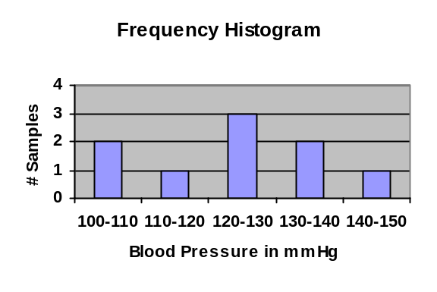
- Using the same data from the previous problem, calculate the mean systolic blood pressure in the sample. Please show your work. [2]
124 mmHg
- Using the same data from the previous problem, calculate the standard deviation of the systolic blood pressure in the sample. Please show your work. [4]
~15.18 mmHg
- Using the same data from the previous problem, draw a boxplot for the data. Show all your work. [5]
Min=100
Max=148
Med=125
1st=111
3rd=135
- Using the same data from the previous problem, if another patient was added to the sample with a very high blood pressure of 185 mmHg, would you expect the mean or the median to be more robust (resistant) to the outlier? [2]
Median is more robust
- A pharmaceutical company has devised a test for a certain kind of cancer. Assume that if a person has the cancer, the test has a 90% chance of detecting it (90% sensitivity). Assume that if a person does not have the cancer, the test has a 2% chance of giving a false positive (98% specificity).
  - Suppose 1000 people use the test, and that 30 of those people really have this kind of cancer. Draw an event tree for the outcomes of the test, and label the tree with probabilities for each branch of the tree. [4]
Cancer: 3%
No cancer: 97%
Test +: 90%
Test -: 10%
Test +: 2%
Test -: 98%
  - What is the probability that a randomly chosen person from this group will test positive for cancer? [2]
(.03)(.90) + (.97)(.02) = 4.64%
  - Suppose that a randomly chosen person from this group does test positive. What is the probability that this person really has this kind of cancer? [2]
(.03)(.90)/.0464 = ~58.19%
- The weight of a population of infants is normally distributed with mean 10.4kg and standard deviation 4.6kg.
  - A particular baby weighs 13.85kg. What percentile does its weight rank on the growth chart? [3]
77.34th percentile
  - What is the 85th percentile weight? [2]
~15.18 kg
  - What is the probability that an infant in this population weighs between 8.974 kg and 13.85kg? [3]
39.51%
- Let A represent people aged under 35. Let B represent smokers. Translate each of the following statements into an equation using A and B, and (where appropriate) draw a Venn diagram in the box provided, shading in the region described.
  - 40% of the people in this study are aged under 35. [2]
P(A) = 0.40
A
  - In this study, the probability that someone smokes is 30%. [2]
P(B) = 0.30
B
  - 20% of the smokers in this study are aged under 35. [3]
P(A|B) = 0.20
(Venn diagram not applicable)
- Given the data from the previous problem, what is the probability that a random person in the study is a young smoker (age under 35)? [3]
P(A|B) P(B) = (0.20)(0.30) = 6%
- Given the data from the previous problem, is smoking independent of age in this study? Why? [2]
No: P(A|B) = 20% is not the same as P(A) = 40%.
- The concentration of sarcoplasmic calcium in a population of muscle cells is normally distributed with mean 2.75 micromolar. Approximately 10% of the cells have an unusually high concentration of at least 6 micromolar. Estimate the standard deviation of calcium concentration in this population of cells. [3]
2.54 micromolar
- Assume that the serum cholesterol levels of a population of 19-year-olds have mean 184 mg/dLi and standard deviation 24 mg/dLi.
  - If we select a random group of nine people from this population, what is the probability that the mean of this sample is within ±4 mg/dLi of the population mean? [5]
38.30%
  - What assumptions did you make about the population’s distribution to solve part (a)? [1]
Normally distributed
  - Repeat part (a) with a larger sample size of 64. [3]
~81.64%
  - In answering part (c), is it okay to relax the assumptions listed in part (b)? Why or why not? [2]
Yes, because with a larger sample size,
the SDSM becomes more normal, even if
the original population was not normal
(Central Limit Theorem).

